Mixed Reality: The Nextgen Technology

Mamik Das
CSE 3rd year, HETC
E-mail: mamikd19@gmail.com

Abstract: Mixed reality (MR), sometimes referred to as hybrid reality is the merging of real and virtual worlds to produce new environments and visualizations where physical and digital objects co-exist and interact in real time. Mixed reality takes place not only in the physical world or the virtual world but is a mix of reality and virtual reality, encompassing both augmented reality and augmented vitality via immersive technology. Though there is a vast application of Mixed reality but in his submission focus will be primarily on healthcare and education sector.

Introduction:In recent past there is a growing trend towards Mixed Reality. Mixed reality is the mixture of AR and VR. Mixed reality that starts with the real world – virtual objects are not just overlaid on the real world but can interact with it. In this case, a user remains in the real-world environment while digital content is added to it; moreover, a user can interact with virtual objects. This form of mixed reality can be considered an advanced form of AR.
Mixed reality that starts with the virtual world – the digital environment is anchored to and replaces the real world. In this case, a user is fully immersed in the virtual environment while the real world is blocked out. Sounds like virtual reality, right? In fact it does, but the digital objects overlap the real ones whereas in conventional VR the virtual environment isn’t connected to the real world around a user. To experience this form of mixed reality, you can wear Windows mixed reality headsets.

Related Work:While VR/AR application frontiers are broad, including but not limited to, the education, sports, tourism, real estate, and healthcare industries, Dulude predicts that AR for commerce (i.e. “virtual try-on”) will be the first place for widespread mass adoption. As an example, Dulude passed around his phone for everyone to take turns “trying-on” a makeover complete with red lipstick and false eyelashes via the Sephora app. Another example is WayfairView, an AR app that Hack.Diversity partner company Wayfair developed to allow shoppers to visualize décor in their homes before making a purchase.This is the current project i am working on that will not only let the coustomers decide about the interior decoration but also we will care about security after the design is finished using IoT(Internet of Things).

Application:

Unimersiv
Previously a repository of reviews of VR educational experiences and tutorials, startup firm Unimersiv has recently launched a virtual reality education app of their own.At the time of this writing, three experiences are available. Users can virtually travel to Stonehenge, the International Space Station, or inside the human body. Along with the ability to freely look around the environments, the app provides educational content in the form of narration, pop-up text, and images. All three experiences are well-written and developed, and provide a fascinating and very effective new way to learn about the various subject matters.

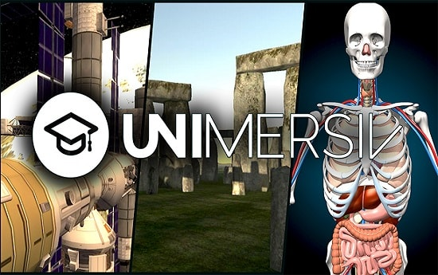
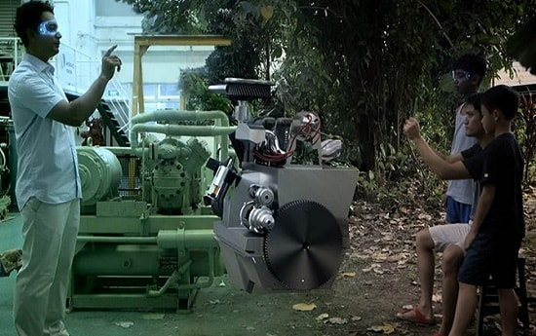

Fig1:Unimersiv tutorial. Fig 2: Eon Reality.
EON reality
Using the EON Creator, educators can select from a vast selection of 3D models and place them within a virtual environment. Text or interactive elements, including content taken from online sources like Wikipedia, are added using simple scripting and drag-and-drop tools from within the virtual environment. The platform supports a wide array of specialized VR and AR hardware developed and deployed by EON.

Hands-On Training
One area where surgeons are already plying their trade with the use of virtual reality is in training. Numerous universities, including Dartmouth and Stanford, are leveraging the new technology both for students to learn and for working professionals to keep their skills sharp.
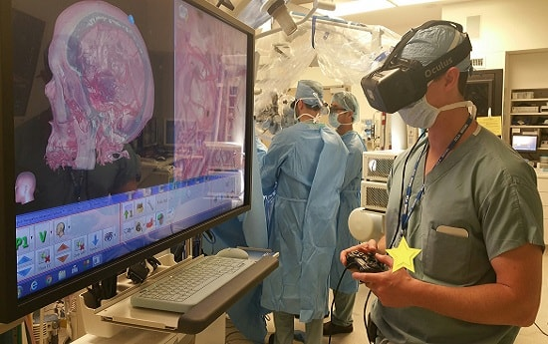
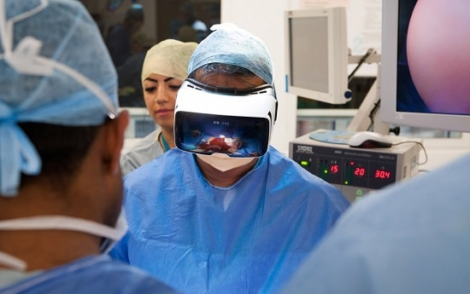

Fig 3: hands on training Fig 4:VR medical Learning.

VR Medical Learning
One firm is leveraging VR to bring healthcare learning to the masses. Startup Medical Realities hosted the first worldwide virtual reality livestream of a surgery earlier this year, and about 50,000 people watched the event on their desktops, phones, and Gear VR head-mounted displays.

Conclusion:The conventionally held view of a Virtual Reality (VR) environment is one in which the participant-observer is totally immersed in, and able to interact with, a completely synthetic world. Such a world may mimic the properties of some real-world environments, either existing or fictional; however, it can also exceed the bounds of physical reality by creating a world in which the physical laws ordinarily governing space, time, mechanics, material properties, etc. no longer hold. What may be overlooked in this view, however, is that the VR label is also frequently used in association with a variety of other environments, to which total immersion and complete synthesis do not necessarily pertain, but which fall somewhere along a virtuality continuum. In this paper we focus on a particular subclass of VR related technologies that involve the merging of real and virtual worlds, which we refer to generically as Mixed Reality (MR).

